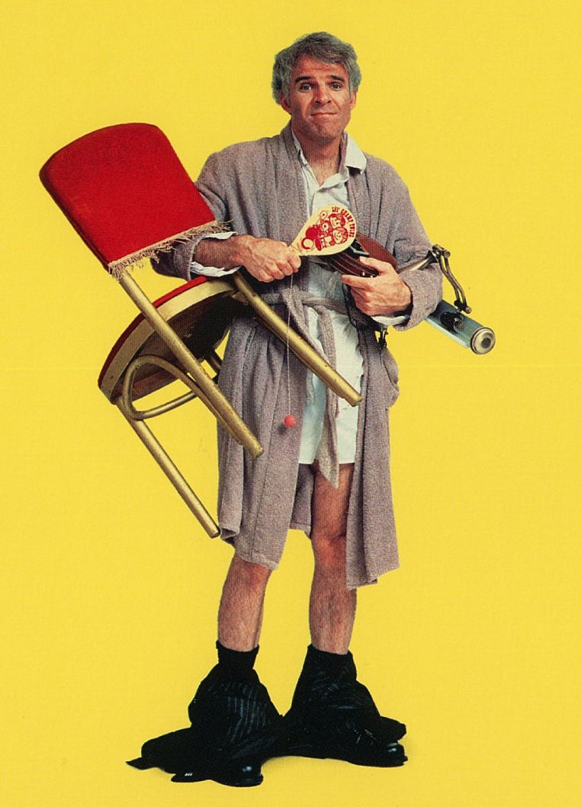All Your Friends Are Jerks\*

Hello Ashton,

Happy birthday to you! And welcome to your very own ARPG (alternate reality puzzle game). Did you know all your friends are jerks? It's true. I had this lovely gift all picked out for you and stuff. But because your friends are all secretly jerks, they've stolen all the pieces of your birthday prize and won't give them back. Fear not! I think we can fix it. You just need the right words.

Here's how it's going to work:

- There are 10 pieces of your present to recover.

- Start a conversation with another ARPG player by saying "Hey, you jerk."

- They will say "What do you want, Birthday Boy?"

- If they don't, apologize. Perhaps offer them some pie if you can

- In ARPG mode, they will be "in character" until they walk away or hang up.

- This game has NO time limit but at least one piece is in the wild and could conceivably be taken by a passerby.

- You can always check with Donovan that the puzzle is working as planned by saying the words: "Y'know you're a jerk." and then following the usual protocol

Here's your first clue....

Amy

Konami

Have fun!

**\*Of course your friends aren't really jerks. They've all agreed to do this because they like you and they like having fun with you, especially because it's your birthday. However, I might be a jerk. You’ll never know for sure unless you play!**